Resources

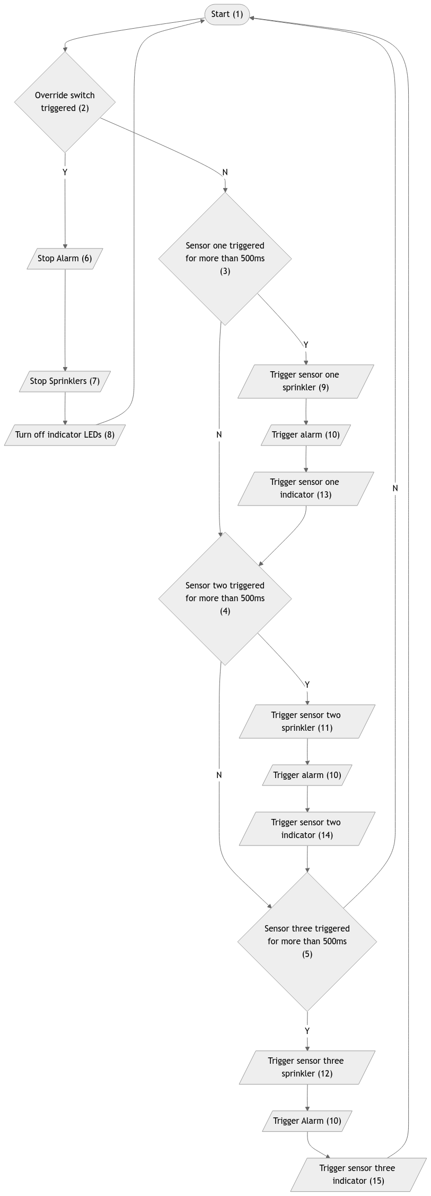
Flowchart

Code
;*******************************************************************
; TEMPLATE PROVIDED BY CENTRE FOR USE WITH HEADER FILE
;
; TITLE: #### Microcontroller fire alarm system #####
; AUTHOR: ######## Tye #########
; DATE: ####### 2024/10/14 ######
;

;******************************************************************
; PROGRAM DESCRIPTION:
;
; #### Checks if a fire has started & triggers alarms & sprinklers in response #######
;
;******************************************************************

;*********************************************************************
; DEFINITIONS
;*********************************************************************
;The header file can be used with either the PIC16F88 or PIC16F877A
;#define UseRC ; UseRC, UseCrystal or UseInternal - defaults to UseRC
#define UseInternal ; UseRC, UseCrystal or UseInternal - defaults to UseRC
#define UseInterrupt
;#define Watchdog ; The Watchdog timers are off by default unless this is uncommented

;#include "Header.inc" ;Predefined wait subroutines - wait1ms, wait10ms, wait100ms, wait1000ms
;Predefined ADC subroutines - readadc0, readac1, readadc2
; radix dec ; set default number radix to decimal
;radix hex ; set default number radix to hex

;*********************************************************************
; VARIABLES
;*********************************************************************

; #### Create any variables here using the EQU statement
;
;
; #### e.g. myVar equ b1

;*********************************************************************
; MAIN PROGRAM
;*********************************************************************

; ---------- Initialisation ----------
init:
; Clears inputs & outputs
clrf PORTB
clrf PORTA

bsf STATUS,RP0 ; Allows writing to TRISx (memory page 1)

; Sets B.x Output
movlw h'00'
movwf TRISB
; Sets A.x Input
movlw h'FF'
movwf TRISA

bcf STATUS,RP0 ; Locks TRISx (memory page 0)

vars:
; Stores how many times each spinkler has been triggered
Sprinkler_One_Count EQU B0
Sprinkler_Two_Count EQU B1
Sprinkler_Three_Count EQU B2

; Stores the result of calculations
Result EQU B3

; Init all vars to 0
movlw h'0'
movwf Sprinkler_One_Count
movwf Sprinkler_Two_Count
movwf Sprinkler_Three_Count
movwf Result

; ---------- Main Cycle ----------
main:
; Test for override.
btfsc PORTA, 1
goto override_switch

; Run spinklers
btfsc PORTA, 0
call spk_one_guard
btfsc PORTA, 7
call spk_two_guard
btfsc PORTA, 6
call spk_three_guard

; Reset spk counts (if appropriate)
btfss PORTA, 0
call zero_spk_one_count
btfss PORTA, 7
call zero_spk_two_count
btfss PORTA, 6
call zero_spk_three_count

; Wait for awhile
call wait100ms

goto main

; ---------- Override Switch ----------
override_switch:
clrf PORTB

; Reset counts for spinkler triggers
movlw h'00'
movwf Sprinkler_One_Count
movwf Sprinkler_Two_Count
movwf Sprinkler_Three_Count
goto main

; ---------- Sprinkler One ----------
spk_one_guard:
; Set Result 0 if count is not 5.
btfss Sprinkler_One_Count, 0
bsf Result, 0
btfss Sprinkler_One_Count, 2
bsf Result, 0

; Increment in place if bellow 5.
btfsc Result, 0
incf Sprinkler_One_Count, 1

; Trigger if 5.
btfss Result, 0
call spk_one_trigger

bcf Result, 0 ; Reset Result reg.
return

spk_one_trigger:
; Trigger,
bsf PORTB, 0 ; Alarm
bsf PORTB, 1 ; Sensor one indicator
bsf PORTB, 4 ; Sensor one sprinkler
return

; ---------- Sprinkler Two ----------
spk_two_guard:
; Set Result 0 if count is not 5.
btfss Sprinkler_Two_Count, 0
bsf Result, 0
btfss Sprinkler_Two_Count, 2
bsf Result, 0

; Increment in place if bellow 5.
btfsc Result, 0
incf Sprinkler_Two_Count, 1

; Trigger if 5.
btfss Result, 0
call spk_two_trigger

bcf Result, 0 ; Reset Result reg.
return

spk_two_trigger:
; Trigger,
bsf PORTB, 0 ; Alarm
bsf PORTB, 2 ; Sensor two indicator
bsf PORTB, 5 ; Sensor two sprinkler
return

; ---------- Sprinkler Three ----------
spk_three_guard:
; Set Result 0 if count is not 5.
btfss Sprinkler_Three_Count, 0
bsf Result, 0
btfss Sprinkler_Three_Count, 2
bsf Result, 0

; Increment in place if bellow 5.
btfsc Result, 0
incf Sprinkler_Three_Count, 1

; Trigger if 5.
btfss Result, 0
call spk_three_trigger

bcf Result, 0 ; Reset Result reg.
return

spk_three_trigger:
; Trigger,
bsf PORTB, 0 ; Alarm
bsf PORTB, 3 ; Sensor three indicator
bsf PORTB, 6 ; Sensor three sprinkler
return

; ---------- Count Resets ----------
zero_spk_one_count:
movlw h'00'
movwf Sprinkler_One_Count
return
zero_spk_two_count:
movlw h'00'
movwf Sprinkler_Two_Count
return
zero_spk_three_count:
movlw h'00'
movwf Sprinkler_Three_Count
return

;*********************************************************************
; INTERRUPT SERVICE ROUTINE
;*********************************************************************

W_SAVE EQU B20 ; backup registers used in interrupts

interrupt:
movwf W_SAVE ; Copy W to save register
btfss INTCON,INT0IF ; check correct interrupt has occurred
retfie ; no, so return and re-enable GIE

;**********The interrupt service routine (if required) goes here*********

bcf INTCON,INT0IF ; bit clear so clear interrupt flag

movf W_SAVE,W ; restore W
retfie ; return and re-set GIE bit

END ; all programs must end with this

Photo Of Circuit
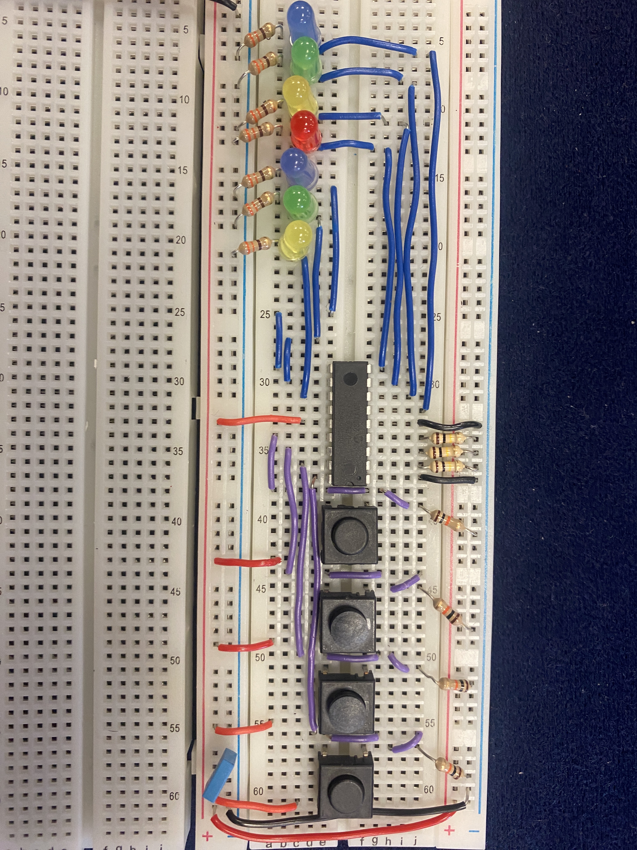

Testing Circuit Evidence
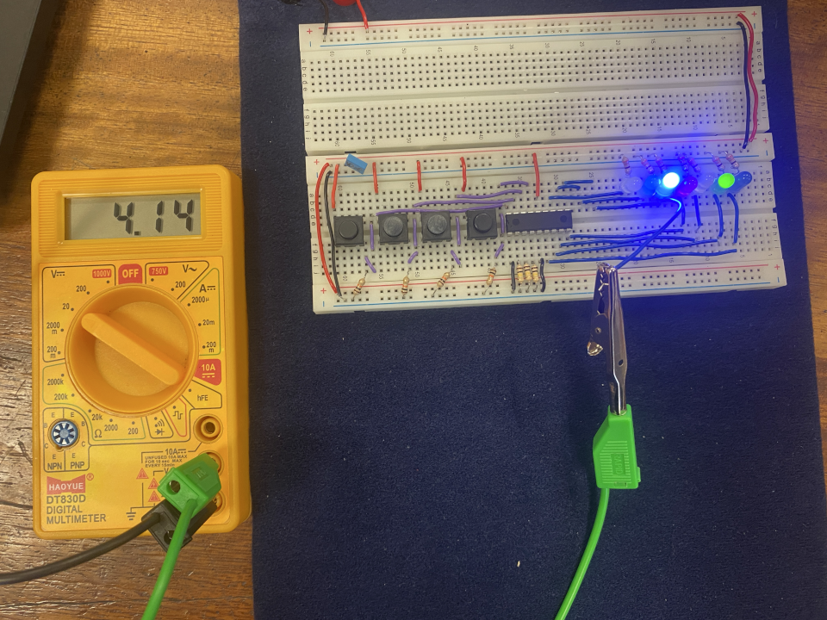

Improvement One Code

vars
vars:
; Stores how many times each spinkler has been triggered
Sprinkler_One_Count EQU B0
Sprinkler_Two_Count EQU B1
Sprinkler_Three_Count EQU B2

; --- Improvment Start ---
; Override count
Override_Count EQU B4
; --- Improvment End ---

; Stores the result of calculations
Result EQU B3

; Init all vars to 0
movlw h'0'
movwf Sprinkler_One_Count
movwf Sprinkler_Two_Count
movwf Sprinkler_Three_Count
movwf Result

; --- Improvment Start ---
movwf Override_Count
; --- Improvment End ---

main
; ---------- Main Cycle ----------
main:
; Test for override.
btfsc PORTA, 1
; --- Improvment Start ---
call override_switch
; --- Improvment End ---

; Run spinklers
btfsc PORTA, 0
call spk_one_guard
btfsc PORTA, 7
call spk_two_guard
btfsc PORTA, 6
call spk_three_guard

; Reset spk counts (if appropriate)
btfss PORTA, 0
call zero_spk_one_count
btfss PORTA, 7
call zero_spk_two_count
btfss PORTA, 6
call zero_spk_three_count

; --- Improvment Start ---
; Reset Override (if appropriate)
btfss PORTA, 1
call zero_override_count
; --- Improvment End ---

; Wait for awhile
call wait100ms

goto main

override_switch
; --- Improvment Start ---
; ---------- Override Switch ----------
override_switch:
; Set Result 0 if count is not 5.
btfss Override_Count, 0
bsf Result, 0
btfss Override_Count, 2
bsf Result, 0

; Increment in place if bellow 5.
btfsc Result, 0
incf Override_Count, 1

; Trigger if 5.
btfss Result, 0
call override_switch_trigger

bcf Result, 0 ; Reset Result reg.
return

override_switch_trigger:
clrf PORTB

; Reset counts for spinkler triggers
movlw h'00'
movwf Sprinkler_One_Count
movwf Sprinkler_Two_Count
movwf Sprinkler_Three_Count
return

zero_override_count:
movlw h'00'
movwf Override_Count
return
; --- Improvment End ---

Improvement Two Circuits

Improved Testing Configuration
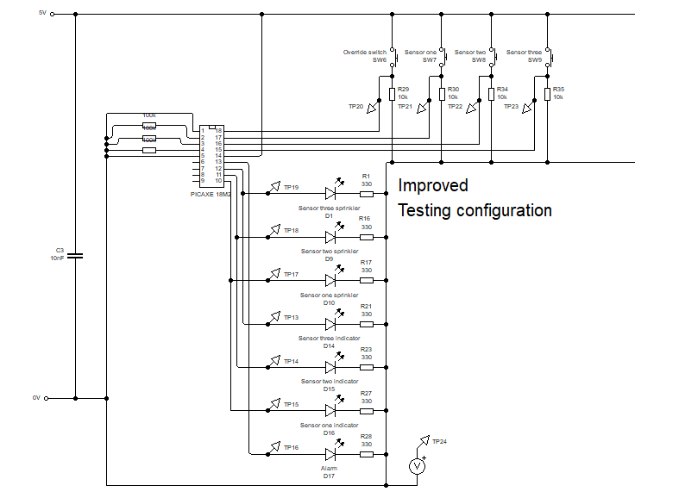

Improved Deployed Configuration
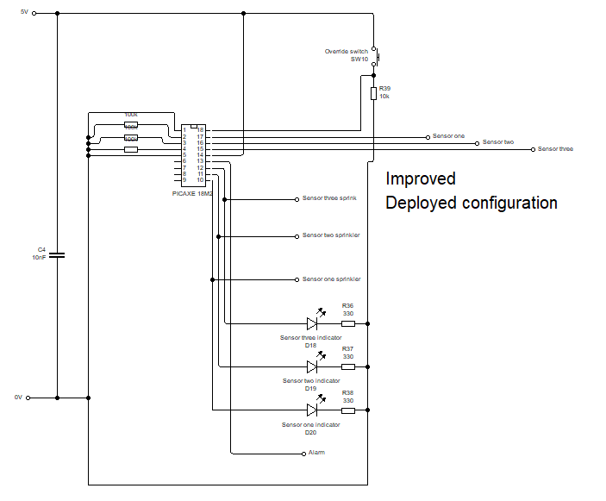

Deployed Configuration
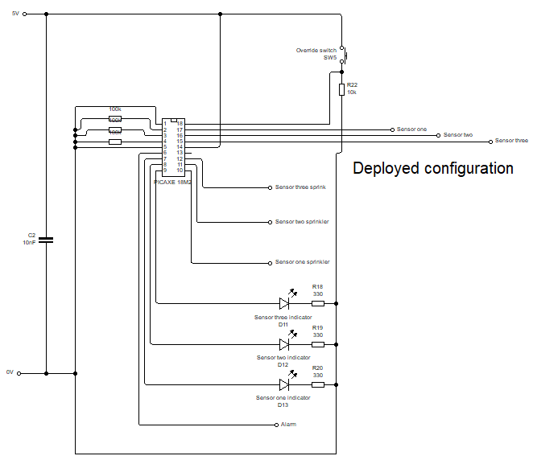

Testing Configuration


